Intercooler Coolant Temperature Gauge Display – CGEA1.3

Functional Description

The purpose of the Intercooler Coolant Temperature (ICT) gauge display is to provide a digital and graphical read out of the temperature of coolant in the supercharger.

The intercooler coolant temperature is measured by the PCM. The ICT Gauge display correlates the EngInnrClnt_Te_Actl signal on the CAN bus from the PCM and the Operational Mode to display the temperature in degrees Fahrenheit or degrees Celcius, depending on the selected units.

The PCM is responsible for any filtering of the data and the Instrument cluster only needs to display the information it receives. The Instrument cluster is responsible for any scaling or unit changes that are required. The ICT shall follow the globally selected units and display its value in either English or Metric units. The display range is dependent on program definition. The virtual gauge sweep, with linear scaling, is based on the HMI for the implementing program. This gauge does not require any red indications because it does not provide warning of any fault condition.

There is a digital numeric and graphical virtual gauge that displays the temperature of coolant in the supercharger. The ICT Gauge pointer shall rotate from bottom to top or left to right to register increasing temperature and rotate in the opposite direction for decreasing temperature.

Interfaces

Interface Context Diagram (I/O Block Diagram)
Figure 1 Intercooler Coolant Temperature Gauge Display Context Diagram
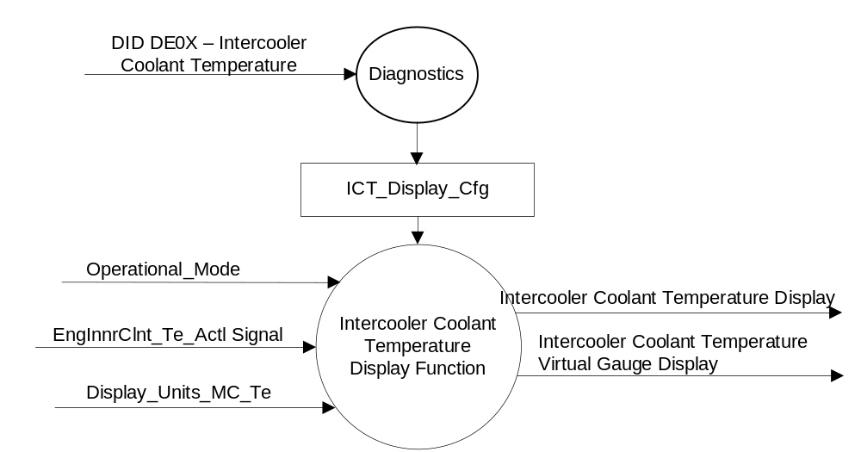

Inputs

- Internal:
- Operational_Mode
- ICT_Display_Cfg
- Display_Units_MC_Te – Refer to the Display Unit Selection Control Function – CGEA STSS for more information.
- MUX message on the HS_CAN Bus

- EngInnrClnt_Te_Actl Signal
Signal Name | Size  (bits) | Detail | Units | Res. | Offset | State Encoded | Min. | Max.
EngInnrClnt_Te_Actl | 7 |  | degC | 1 | -20 |  | -20  (0x0) | 127  (0x7F)
 |  | No Data Exists |  |  |  | 0x7E
 |  | Faulty |  |  |  | 0x7F

Outputs
- Intercooler Coolant Temperature Display
- Intercooler Coolant Temperature Virtual Gauge Display

Function/Performance

Operational Modes

Mode | Differentiating Vehicle Conditions
Sleep Mode | Intercooler Coolant Temperature display / virtual gauge inactive
Limited Mode | Intercooler Coolant Temperature display / virtual gauge inactive
Normal Mode | Intercooler Coolant Temperature display / virtual gauge active/inactive
Crank Mode | Intercooler Coolant Temperature display / virtual gauge active/inactive

Voltage Levels

Refer to the Cluster Features table located in the Operational Modes and Voltage Range Strategies Section of this SPSS.

Human-Machine Interface

Visual

Indicator Graphics / Display Format
Final graphics to be provided by product specific HMI wallpaper. Below is an example:

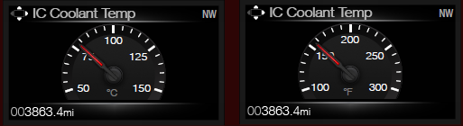

Indicator Color Coordinates

Indicator Characteristics

Description of Gauge | Scale Range | Scale Span | Operating Span
North American | Per program definition | HMI based | Per program/HMI definition

Audio

None

Switch Control Logic

Not Applicable

System Accuracy

- Shall indicate the data contained in EngInnrClnt_Te_Actl Signal.

Operation: Performance and Functional

Subsystem Algorithm Flowchart / State Diagram

Figure 2: Intercooler Coolant Temp Diagnostic Configuration

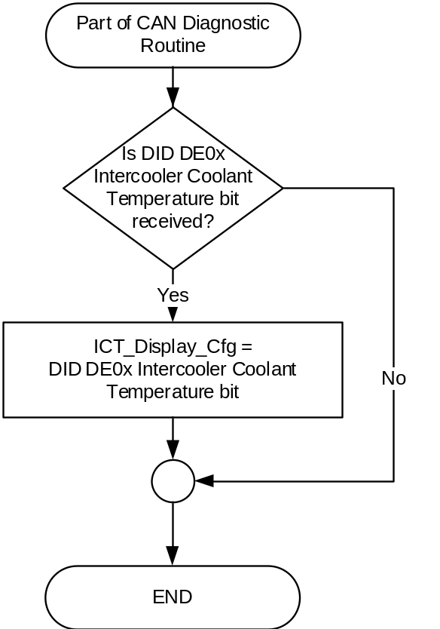

Figure 3: Intercooler Coolant Temperature Display Process
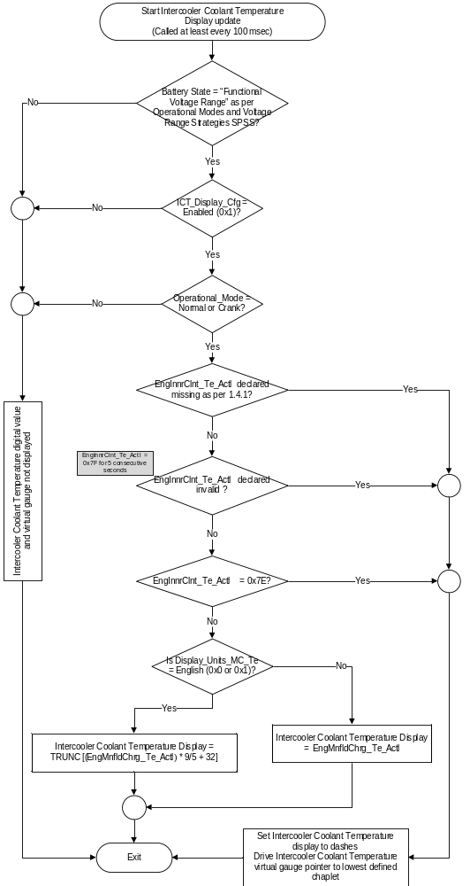

Figure 3: Intercooler Coolant Temperature Virtual Gauge Display Process

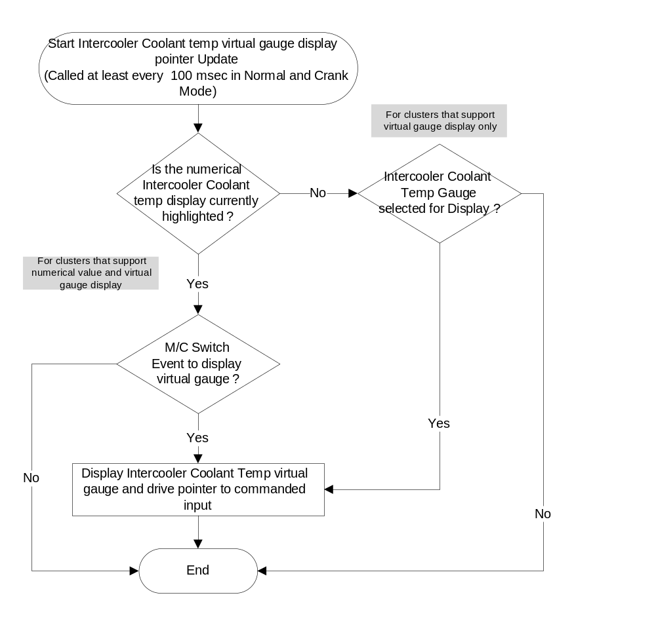

Example graphic shown above.
Final range based on program definition and HMI theme.

Operation Description (supports algorithm flowchart /state diagram)

- Gauge pointer shall move to the min pointer position ("Rest Position") at max rate when EngInnrClnt_Te_Actl is declared missing or invalid as per section 1.4, or EngInnrClnt_Te_Actl is received with Unknown data (0x7E).
- The Intercooler Coolant Temperature virtual Gauge display shall not exhibit needle waver exceeding 1/3 of an angular degree with a steady commanded input.
- Pointer overshoot and return to temperature indicated by contained EngInnrClnt_Te_Actl Signal shall not exceed one angular degree.
- The Intercooler Coolant Temperature display and virtual Gauge display shall sample the contained in EngInnrClnt_Te_Actl Signal at the predefined message's periodic rate.
- The cluster shall update the virtual gauge pointer position at least every 100 msec since the Intercooler Coolant Temp virtual gauge has a high degree of pointer movement.
- The cluster shall linear interpolate between input values to calculate the target position to ensure smooth pointer movement between targets.
- The Intercooler Coolant Temperature display and the virtual gauge shall not be displayed if ICT_Display_Cfg is Disabled (0x0).

Function Safety Classification (EMC)

B

Memory Storage

Parameter Name | Description | Value at  Battery Connect | Value at  Module Wake-up
Intercooler Coolant Temperature Display | Displays the numerical value of the intercooler coolant value in selected units. | Inactive | Inactive
Intercooler Coolant Temperature Virtual Gauge display | Use to display virtual Intercooler Coolant gauge display | Inactive | Inactive
EngInnrClnt_Te_Actl Signal | CAN signal sent from the PCM for Inlet Air Temperature | -20 C (0x0) | -20 C (0x0)
ICT_Display_Cfg | State indicator for feature presence controlled via CAN at EOL at VO plant. Set to Disabled at Cluster Supplier Manufacturing Plant | Use Stored Value | Use Stored Value
Operational_Mode | 4 state indicator for cluster operational mode | Limited | Limited, Normal or Crank

Prove Out

No

Error Handling

Missing Message Strategy

The signals will be declared missing as per the Diagnostics section of this SPSS.

DTCs states and history will be determined as per the Diagnostics section of this SPSS.

If ICT_Display _Cfg = Disabled, the cluster shall never log a missing message DTC due to this feature.

Invalid Message Strategy

The signal data will be declared invalid as per the Diagnostics section of this SPSS.

DTCs states and history will be determined as per the Diagnostics section of this SPSS.

If ICT_Display _Cfg = Disabled, the cluster shall never log an invalid data DTC due to this feature.

Diagnostics

Self Test
None.

Engineering Test Mode

Reference section “Dealer / Engineering Test Mode (ETM)”

Part II Performance

Supported Diagnostic Trouble Codes (DTCs)
DTC | Description
C10000 | Lost Communication with PCM
C40100 | Invalid Data Received from PCM

DID DE0X
Block  Num | Block Description | Size (bits) | Byte | Bit | State: Description | "0" | "1" | Default | Comments
PACKETED BLOCKS
$XX | Option Content (B&A) | 1 | * | * | Intercooler Coolant Temperature | Disabled | Enabled | Disabled | Disabled means the virtual gauge is not to be displayed in the cluster.
*Byte and bit location to be identified in Part II Specification for this cluster

Reference Specification

- Func. Criticality EC-0048
- Mod. PWR-up / Reset EC-0049
- Low-High Vol. Perform. EC-0058
- Jump Start EC-0062
- Instr. & Gauges (indic. Grad) IS-0015
- Oper. Voltage Perf. IS-0052
- Oper. Voltage Func. IS-0053
- Sys. Audible Noise IS-0103
- Pointer Waver IS-0108
- Instr. Scale Dir. IS-0127
- Symbol Usage 01-0238 / 01-0239
- Symbol Leg. 01-0240
- Placement - Parts Loc. 03-0001
- Glare/Reflections 16-0068
- Reflection 17-0018
- Harmony: Graphics / Font / Ill. 17-0040
- Ergo - Access. 17-0052
- Ergo - Operablility 17-0053
- Control & Display Loc. 17-0060
- Logical grouping Function and Usage 17-0062
- Assoc. of Controls with Disp. & elem. 17-0063
- Ill. Controls & Disp. 17-0074
- Id. Legibility 17-0081
- ID. Coding / Labeling 17-0083
- Logic of Op. 17-0120
- Op. Stereotypes 17-0121
- Interpretation 17-0122
- Feedback 17-0124

Revision History
SPSS Module Revision History

Revision Level | Name | Change Description | Date
1.0 | V.Patel | Initial release | 6/27/2017

